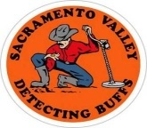
A Nonprofit Organization
The Public is Invited to Attend our Meetings
SVDB Web Site http://www.sacramentovalleydetectingbuffs.com/
Issue Date July 2013

Sacramento Valley Detecting Buffs
2013 Elected Officers

President: Barbara Anderton
lcrbean@aol.com

Vice President: Kyle Miles
ktmiles2@hotmail.com

Secretary: Steve Timmons
Stimm_99@yahoo.com
Treasurer: Charlotte Key
moxieroxie@msn.com
Membership: George Magann
gcmagann@hotmail.com

2013 Volunteer Positions

Hospitality: Al & Linda Woltman
looking4au@ live.com
Hunt Master: Dan Cordes

Librarian: Tom Schweppe ....... .... coottom@aol.com
Newsletter Editor: Steve Timmons
stimm_99@yahoo.com

Raffle Table: Mary Ann Meji, Don Ivers &
James Neeley
nightdustr@aol.com
Web-Site Editors: Bob Meneely
bmeneely@starstream.net

Metal Detecting
Takes you exotic places
Ghost RR Station - Nevada
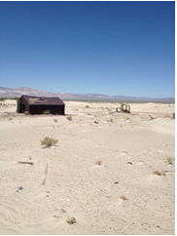

June Meeting Minutes
- Barbara called the meeting to order.

Vice President’s Report:
- Kyle talked about the sale table up front at each meeting. Members can bring in equipment they wish to sell and put it on display throughout the meeting. This meeting had an unusually large amount on display due to Linda from Bay Savers bringing in several used detectors for sale.

Secretary’s Report:
- Steve mentioned the ongoing project of recording how much in coins that members find each month. This is just a curiosity project, so if you are interested, keep track of the dollar amount you find during the month and record it at the next meeting. The first month had eleven people recording their finds for a total of $195.47 or $17.77 average.

Treasurer’s Report: Charlotte Key
- Charlotte reported the financial activity for the month. All expenses of the annual hunt have been paid and the club is in excellent financial condition.

Membership Report: George Magann
- George was absent so there was no membership drawing. There will be two drawings in July.

Web Site Report: Bob Meneely
- Bob spoke about the Mine Labs hunt in Santa Barbara and what good fun it was. He noted that there is a link on our website to Lee Wiese’s web site that lists events around the country like the Mine Labs event for those interested.

Hunt Master Report:
- Dan Cordes, the new hunt master, asked for any suggestions for mini-hunts members might have. He hoped to get some hunts going soon. Help Dan out if you have suggestions.
June 2013 |  |  |  |  |  |  |  | July 2013 |  |  |  |  |  |  |  | August 2013
Su | Mo | Tu | We | Th | Fr | Sa |  | Su | Mo | Tu | We | Th | Fr | Sa |  | Su | Mo | Tu | We | Th | Fr | Sa
 |  |  |  |  |  | 1 |  |  | 1 | 2 | 3 | 4 | 5 | 6 |  |  |  |  |  | 1 | 2 | 3
2 | 3 | 4 | 5 | 6 | 7 | 8 |  | 7 | 8 | 9 | 10 | 11 | 12 | 13 |  | 4 | 5 | 6 | 7 | 8 | 9 | 10
9 | 10 | 11 | 12 | 13 | 14 | 15 |  | 14 | 15 | 16 | 17 | 18 | 19 | 20 |  | 11 | 12 | 13 | 14 | 15 | 16 | 17
16 | 17 | 18 | 19 | 20 | 21 | 22 |  | 21 | 22 | 23 | 24 | 25 | 26 | 27 |  | 18 | 19 | 20 | 21 | 22 | 23 | 24
23 | 24 | 25 | 26 | 27 | 28 | 29 |  | 28 | 29 | 30 | 31 |  |  |  |  | 25 | 26 | 27 | 28 | 29 | 30 | 31
30
Calendar Legend: SVDB Monthly Meetings
Sun Day-in-the-Park Hunts
Sat Day-in-the-Park Hunts

New Business:

- David Harris talked about his trip to Roaring Camp Mining Company in Pine Grove, CA. The fun included gold panning and bringing a boulder home for demolition. He also brought in a T-shirt and bottle of concentrate for auction. Paul Giese did the honors of the auction and it brought in $51.

- Paul Giese also said at the next meeting he will auction off a guided trip to his favorite mining claim. The promise of gold was mentioned. Stay tuned.

- Barbara recounted some of the adventures of dump digging in Tonopah, NV. She found some old bottles including an old ink bottle and a token, but finds were a little scarce.

- Don Dunn talked about the coin buying operation and said he was short of silver dollars. If interested in selling your silver dollars or other coins, see Don. He’s been paying around $26 for silver dollars.

- Kris Wilson has taken over running the 4th Saturday hunt. He will announce if there is a change in meeting place.

- The Board of Directors met on June 23 to cover upcoming issues. They discussed moving the site

for the next annual hunt. A likely site is already selected and would include barbecuing for the lunch. The budget and prizes for the Christmas party were discussed and even the possibility of moving our monthly meeting site since our attendance has grown so greatly over the last year. Also discussed was the possibility of having a silent auction each or every other month for a limited number of members to sell some of their finds at the meetings. All these things will entail more discussion and will be presented at meetings in the future. If you have any ideas or feelings about any of these items, please talk to any Board member or bring it up during a meeting. Al Woltman presented the final cost breakdown of the annual hunt and reported we came in right on budget. Thanks to all who made the hunt a big success.

SVDB Meeting Time and Location Information:
- SVDB Meetings are held at 7:30 pm the first
Thursday of each month (Wednesday July 3 this month due to the holiday) at the Sacramento County Sewer District’s Building in North Highlands, located at the intersection of Elkhorn Blvd. and Don Julio Blvd. Our meeting room is held in a large room facing Elkhorn, close to where all the cars are parked in the parking lot near Elkhorn Blvd. (Mapquest address is 5026 Don Julio Blvd., Sacramento, CA 95842).

Day-In-The-Park Hunts:
- There are 4 day-in-the park hunts per month.
The hunts are on the first, second and third Sundays and the fourth Saturday. Breakfast is at 7:00 am with departure to the hunt site at 8:00 am.
The hunt ends at 11 am. The meeting places for the hunts:
- 1st Sunday Hunt: Meet at Denny’s Watt and Auburn
- 2nd Sunday Hunt: Meet at Denny´s at Sunrise and Zinfandel Dr. (2474 Sunrise Blvd)
- 3rd Sunday Hunt: Meet at Waffle Square 1825 10th St, Sac
- 4th Saturday Hunt: Meet at Denny’s Watt and Auburn

Odds ‘n Ends:

Show & Tell: Don Dunn and John Hainlen and James Neeley all had gold rings to show. In addition James found an imitation $20 gold piece.

The raffle brought in $861.

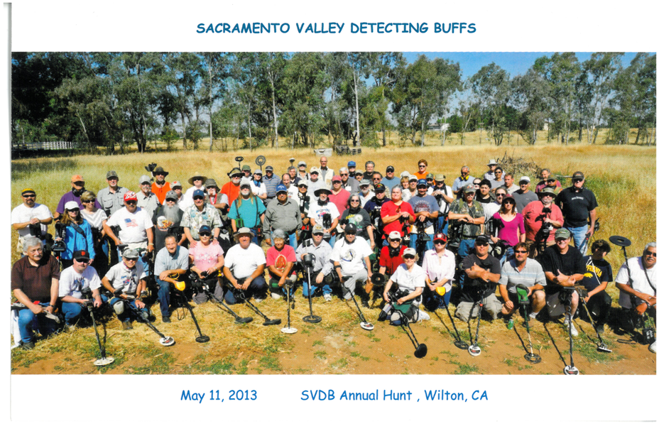

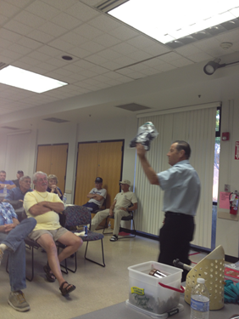
Auction Action

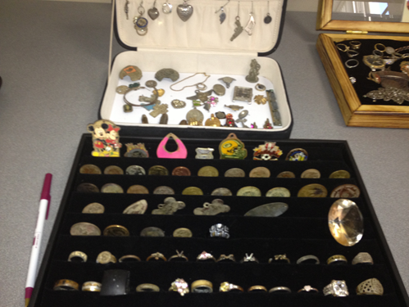
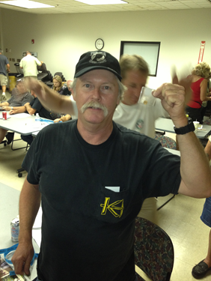
The big winner in June



